CREATING DATABASE

CREATE database NORTHWIND_TRADERS;

ALTER TABLE categories
ADD CONSTRAINT pk_categories PRIMARY KEY (categoryID);

ALTER TABLE customers
MODIFY customerID VARCHAR(50) NOT NULL;

ALTER TABLE customers
ADD CONSTRAINT pk_customers PRIMARY KEY (customerID);

ALTER TABLE employees
ADD CONSTRAINT pk_employees PRIMARY KEY (employeeID);

ALTER TABLE orders
ADD CONSTRAINT orders PRIMARY KEY (orderID);

ALTER TABLE products
ADD CONSTRAINT products PRIMARY KEY (productID);

ALTER TABLE shippers
ADD CONSTRAINT pk_shippers PRIMARY KEY (shipperID);

ALTER TABLE customers
MODIFY customerID VARCHAR(50) NOT NULL;

ALTER TABLE orders
MODIFY customerID VARCHAR(50) NOT NULL;

ALTER TABLE orders
ADD CONSTRAINT fk_orders
FOREIGN KEY (customerID) REFERENCES customers(customerID);

DELETE FROM employees
WHERE employeeID IS NULL;

DELETE FROM orders
WHERE employeeID IS NULL;

SELECT DISTINCT employeeID
FROM orders
WHERE employeeID NOT IN (SELECT employeeID FROM employees)
OR employeeID IS NULL;

INSERT INTO employees (employeeID, employeeName, title, city, country, reportsTo)
VALUES (2, 'Andrew Fuller', 'Vice President Sales', 'New York', 'USA', NULL);

ALTER TABLE orders
ADD CONSTRAINT fk_orders_employees
FOREIGN KEY (employeeID) REFERENCES employees(employeeID);

DELETE FROM shippers
WHERE shipperID IS NULL;

ALTER TABLE orders
ADD CONSTRAINT fk_orders_shippers
FOREIGN KEY (shipperID) REFERENCES shippers(shipperID);

ALTER TABLE order_details
ADD CONSTRAINT fk_orders_details_orders
FOREIGN KEY (orderID) REFERENCES orders(orderID);

DELETE FROM products
WHERE productID IS NULL;

DELETE FROM categories
WHERE categoryID IS NULL;

ALTER TABLE order_details
ADD CONSTRAINT fk_orders_details_products
FOREIGN KEY (productID) REFERENCES products(productID);

ALTER TABLE products
ADD CONSTRAINT fk_products_categories
FOREIGN KEY (categoryID) REFERENCES categories(categoryID);

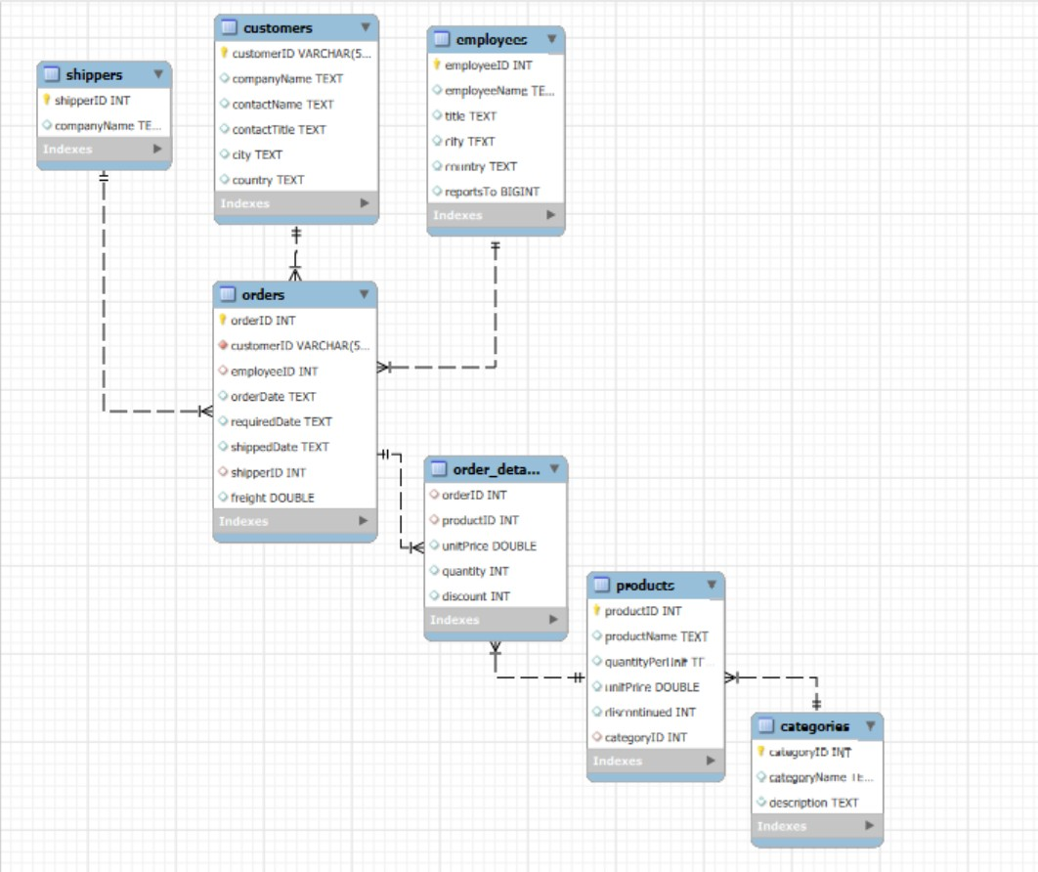

-- SALES THROUGHT TIME

CREATE VIEW sales_throuht_time AS (
SELECT
YEAR(o.orderDate) as Year_,
MONTH(o.orderDate) as Month_,
SUM(od.quantity) as TotalQuantity,
SUM(od.quantity * od.unitPrice) as TotalRevenue,
SUM(o.freight) as TotalFreightCosts,
SUM(od.quantity * od.unitPrice) - SUM(o.freight) as TotalNetRevenue
FROM orders o
LEFT JOIN order_details od ON o.orderID = od.orderID
GROUP BY
YEAR(o.orderDate),
MONTH(o.orderDate)
);

-- CATEGORIES OF PRODUCTS THROUGHT TIME

CREATE VIEW product_categories_throuht_time AS (
SELECT
c.categoryName,
YEAR(o.orderDate) as Year_,
MONTH(o.orderDate) as Month_,
SUM(od.quantity) as TotalQuantity,
SUM(od.quantity * od.unitPrice) as TotalRevenue,
SUM(o.freight) as TotalFreightCosts,
SUM(od.quantity * od.unitPrice) - SUM(o.freight) as TotalNetRevenue
FROM orders o
LEFT JOIN order_details od ON o.orderID = od.orderID
LEFT JOIN products p ON od.productID = p.productID
LEFT JOIN categories c ON p.categoryID = c.categoryID
GROUP BY
c.categoryName,
YEAR(o.orderDate),
MONTH(o.orderDate)
);

-- PRODUCTS THROUGHT TIME

CREATE VIEW products_throuht_time AS (
SELECT
p.productName,
YEAR(o.orderDate) as Year_,
MONTH(o.orderDate) as Month_,
SUM(od.quantity) as TotalQuantity,
SUM(od.quantity * od.unitPrice) as TotalRevenue,
SUM(o.freight) as TotalFreightCosts,
SUM(od.quantity * od.unitPrice) - SUM(o.freight) as TotalNetRevenue
FROM orders o
LEFT JOIN order_details od ON o.orderID = od.orderID
LEFT JOIN products p ON od.productID = p.productID
LEFT JOIN categories c ON p.categoryID = c.categoryID
GROUP BY
p.productName,
YEAR(o.orderDate),
MONTH(o.orderDate)
);

-- CUSTOMERS THROUGHT TIME

CREATE VIEW customers_throught_time AS (
SELECT
c.companyName,
c.country,
c.city,
YEAR(o.orderDate) AS Year_,
MONTH(o.orderDate) AS Month_,
SUM(od.quantity) AS TotalQuantity,
SUM(od.quantity * od.unitPrice) AS TotalRevenue,
SUM(o.freight) AS TotalFreightCosts,
SUM(od.quantity * od.unitPrice) - SUM(o.freight) AS TotalNetRevenue
FROM orders o
LEFT JOIN order_details od ON o.orderID = od.orderID
LEFT JOIN customers c ON o.customerID = c.customerID
GROUP BY
c.companyName,
c.country,
c.city,
YEAR(o.orderDate),
MONTH(o.orderDate)
);

-- SHIPPERS TO CUSTOMERS QUANTITY AND REVENUE THROUGHT TIME

CREATE VIEW shippers_throught_time_per_country AS (
SELECT
c.country,
YEAR(o.orderDate) AS Year_,
MONTH(o.orderDate) AS Month_,

-- SPEEDY EXPRESS
SUM(CASE WHEN s.companyName = 'Speedy Express' THEN od.quantity ELSE 0 END) AS Total_Speedy_Express_Quantity,
SUM(CASE WHEN s.companyName = 'Speedy Express' THEN od.quantity * od.unitPrice ELSE 0 END) AS Total_Speedy_Express_Revenue,
SUM(CASE WHEN s.companyName = 'Speedy Express' THEN o.freight ELSE 0 END) AS Total_Speedy_Express_FreightCosts,
SUM(CASE WHEN s.companyName = 'Speedy Express' THEN od.quantity * od.unitPrice ELSE 0 END)
- SUM(CASE WHEN s.companyName = 'Speedy Express' THEN o.freight ELSE 0 END)
AS Total_Speedy_Express_NetRevenue,

-- UNITED PACKAGE
SUM(CASE WHEN s.companyName = 'United Package' THEN od.quantity ELSE 0 END) AS Total_United_Package_Quantity,
SUM(CASE WHEN s.companyName = 'United Package' THEN od.quantity * od.unitPrice ELSE 0 END) AS Total_United_Package_Revenue,
SUM(CASE WHEN s.companyName = 'United Package' THEN o.freight ELSE 0 END) AS Total_United_Package_FreightCosts,
SUM(CASE WHEN s.companyName = 'United Package' THEN od.quantity * od.unitPrice ELSE 0 END)
- SUM(CASE WHEN s.companyName = 'United Package' THEN o.freight ELSE 0 END)
AS Total_United_Package_NetRevenue,

-- FEDERAL SHIPPING
SUM(CASE WHEN s.companyName = 'Federal Shipping' THEN od.quantity ELSE 0 END) AS Total_Federal_Shipping_Quantity,
SUM(CASE WHEN s.companyName = 'Federal Shipping' THEN od.quantity * od.unitPrice ELSE 0 END) AS Total_Federal_Shipping_Revenue,
SUM(CASE WHEN s.companyName = 'Federal Shipping' THEN o.freight ELSE 0 END) AS Total_Federal_Shipping_FreightCosts,
SUM(CASE WHEN s.companyName = 'Federal Shipping' THEN od.quantity * od.unitPrice ELSE 0 END)
- SUM(CASE WHEN s.companyName = 'Federal Shipping' THEN o.freight ELSE 0 END)
AS Total_Federal_Shipping_NetRevenue

FROM order_details od
LEFT JOIN orders o ON od.orderID = o.orderID
LEFT JOIN customers c ON o.customerID = c.customerID
LEFT JOIN shippers s ON o.shipperID = s.shipperID

GROUP BY
c.country,
YEAR(o.orderDate),
MONTH(o.orderDate)
);

